Environmental Science Name______________________________

Period_____

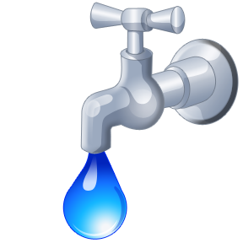 How much water does my family use?
Objective:
The supply of water seems to be endless. Every time we turn on the tap we get water. In some places this is not always the case. By completing this activity, you'll be amazed to find out how much water your family actually uses. Also, you may discover that you can save money by identifying ways in which you're wasting water.

Water Usage
ACTIVITY | AMOUNT
Bath | 25 gallons
Dishwasher | 14 gallons
Fire Hydrant | 1,000 gallons per minute (fully opened)
Flushing the Toilet | 5 gallons per flush
Lawn Watering | 10 gallons per minute
Leaky Faucet | 15 gallons of water per day
Shower | 10 gallons per minute
Washing Machine | 40 gallons per load

Step 1
Calculate how much water is used in your home for showers, using the chart above.
You need to calculate the following:

________ | X | ________ | = | __________
the number of showers per week |  | the average minutes per shower |  | showering minutes per week
________ | X | ________ | = | __________
showering minutes per week |  | gallons per minute used showering |  | total gallons used per week for showers

Step 2

Figure out the number of gallons you use in a week for the activities listed below.
Gallons Used in a Week
Activity | Times per Week | Gallons Used per Activity | Total Gallons Used
Dishwasher | _______ | ________ | _______
Flushing the Toilet | _______ | ________ | _______
Taking a Bath | _______ | ________ | _______
Lawn Watering | _______ | ________ | _______
Doing Laundry | _______ | ________ | _______
Car Washing | _______ | ________ | _______
Showers | The total gallons used for showers can be obtained from the results in step 1. |  | _______
 |  | Total Usage | _______

Step 3
Assume you have a leaky faucet in your kitchen. If the faucet leaks for two weeks, how much water would be wasted?
________ | X | ________ | = | __________
gallons wasted per day |  | number of days |  | number of gallons wasted
Step 4

Now let's look at the bigger picture by answering the following questions.
- How would your life be affected if you turned on the faucet and no water came out?

- What states in the United States have water shortages and why?

- Name three countries that have a shortage of water. How are they resolving the problem? Where did you find your information?

