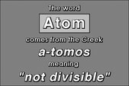**Timeline of the Atom**

1904

1911

400BC

1869

1790’s

1909

1922

1897

1808

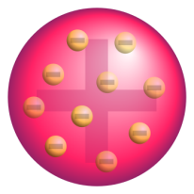 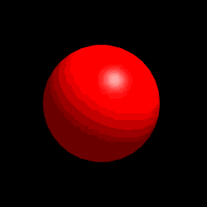

**Law of Conservation of Mass**- Matter is neither created nor destroyed

**Law of Definite Proportions**- A chemical compound contains the same elements in the same proportions by mass regardless of the size of the sample or source of the compound is known

Ernest Rutherford’s gold foil experiment provided evidence for a positive bundle of matter called the nucleus and drew up a model of the positively charged nucleus in the center surrounded by the electrons. Most of the volume of the atom is space. Disproved the “Plum Pudding” model.

J. J. Thomas hypothesized the “Plum Pudding” model of the atom. The atom is composed of electrons surrounded by a soup of positive charge to balance out the negative charge of the electrons.

Greek Philosopher, Democritus, hypothesized that all matter (plus space and time) is composed of tiny indestructible units, called atoms, that are the smallest units of elements. Between atoms was empty space.

J. J. Thomson researches and names the electron using a Cathode Ray experiment. He found out its mass to charge ratio.

Niels Bohr discussed that electrons move in specific orbital patterns around the nucleus.

John Dalton’s Atomic Theory:

1. All matter is composed of extremely small particles called atoms

2. Atoms of a given elements are identical in size, mass and other properties; atoms of different elements differ in size, mass, and other properties

3. Atoms cannot be subdivided, created, or destroyed

4. Atoms of different elements combine in simple whole-number ratios to form chemical compounds

5. In chemical reactions, atoms are combined, separated, or rearranged

**Law of Multiple Proportions-** If two or more different compounds are composed of the same two elements, then the ratio of the masses of the second element combined with a certain mass of the first element is always a ratio of small whole numbers

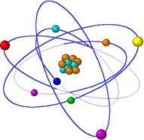

Mendeleev drew a table outlining various elements arranged into 7 groups of similar properties known as the Periodic Table