Name_______________________Period____

Stages in Ecological Succession

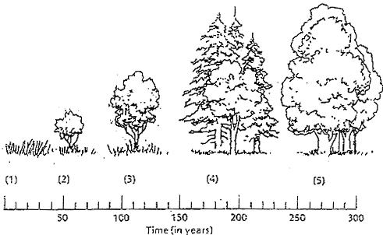

Briefly explain what is happening in the diagram above.
1. ___________________________________________________________________________________________________________________________
2. ___________________________________________________________________________________________________________________________
3. ___________________________________________________________________________________________________________________________
4. ___________________________________________________________________________________________________________________________
5. ___________________________________________________________________________________________________________________________

