

**Significant digits** represent numbers that are actually measured. How many digits can be measured depends on the ability of the measuring device. For instance, a digital stopwatch may measure hundredths of a second while one with a sweep hand may only measure fifths.   
**Use this webtest to practice significant digits.**



**Scientific notation** is a way to write very large or very small numbers.



**Use this webtest to practice scientific notation.**



**In-class Assignment 022:**



What are qualitative properties?

1. What is a "significant digit"?
2. How many zeros would be in this number, **3.445 X 1014** , if it were written out completely?
3. How do you determine whether to write a number normally, or use scientific notation?
4. What is meant by a "scientific" calculator?
5. Work both sets of practice problems on the **significant digit page**.



**Significant digits:**



* **A significant digit is one which is actually measured.**
* The number of significant digits in a measurement depends on the ability of the measuring device.

|  |  |
| --- | --- |
|  | *When a calculation involves measurements with different numbers of significant digits, the answer should have the same number of significant digits as the* ***least*** *in the measurements.* |

|  |  |
| --- | --- |
| |  | | --- | | **Rules for assigning significance to a digit:**   1. **Digits other than zero are always significant.** 2. **Rules about zeros:**     1. **Final zeros after a decimal point are always significant.**    2. **Zeros between two other significant digits are always significant.**    3. **Zeros used only to space the decimal are never significant.** | |

|  |  |
| --- | --- |
| |  | | --- | | **Practice problems:**   1. A soil sample, as received by a laboratory, weighed 5.6165 g. After drying in an oven, this same sample weighed 2.7749 g. What is the percentage of moisture in the sample? 2. Determine the number of significant digits in each of these:    1. 6.751 g    2. 0.157 kg    3. 28.0 ml    4. 2500 m    5. 0.070 g    6. 30.07 g    7. 0.0067 cm    8. 6.02 x 1023 atoms | |



**Uncertainty in measurement:**



* No matter the measuring tool, there will always be some uncertainty in the measurement.
* **Both the tool and its user will add their own uncertainty to the measurement.**
* Use **this tutorial** to become familiar with measurement uncertainty.



**Reliability of measurement:**

* **Accuracy** - refers to how close a measurement is to the true value of the quantity.
* **Precision** - refers to how close a set of measurements for a quantity are to one another, regardless of whether they are correct.

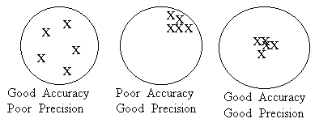

**Experimental error** - the comparison of an experimental value to a known value. This calcuation is used to determine how well your experimental measurements are done.

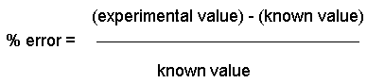

|  |  |
| --- | --- |
| |  | | --- | | **Practice problems:**   1. An experiment produces data indicating that the formula mass of water is 16 amu. The formula mass of water is known to be 18 amu. What percent of error occured in this experiment? 2. A laboratory scale measures the mass of a cubic decimeter of water to be 850 grams. What is the percent of error in this laboratory scale? | |