**Seed Identification and Dissection Lab**

**Purpose**

The purpose of the lab is to dissect a bean seed in order to identify all of the parts of an embryonic plant (including the cotyledons, embryonic root (radicle), epicotyl, hypocotyls, and seed coat.

**Background Information:**

1. There are two kinds of seed-bearing plants: the flowering plants are called “angiosperms”, and the non-flowering plants are called “gymnosperms”. Most seed plants are the flowering kind. There are over 250,000 species of flowering plants, and only about 600 non-flowering plants. Corn and beans are angiosperm seeds.
2. A seed is a tiny life-support package. All seeds have three parts: a tough covering (seed coat), an embryonic plant consisting of the plumule (embryonic leaves), epicotyl (upper stem), hypocotyls (stem of adult plant), and radical (roots) , and a food supply (cotyledon). The hilum is the site of attachment to the ovary. In plack eyed peas, the “black eye” is the hilum.
3. The outer covering of the seed is called the seed coat. The seed coat helps protect the inside of the seed from insects, disease, and damage. Sometimes the seed coat is smooth and paper-thin like that of a pinto bean. A coconut’s seed coat, however, is rough, thick, and hard. A seed cannot develop into a plant until the seed coat is broken.
4. The embryo is the tiny plant inside the seed. The embryo is the source of the root, stem and leaf structures.
5. Surrounding the embryo is the food supply. The food supply is the seed’s only source of nourishment as it pushes up through the soil and grows into a young plant. When the food supply is gone, a green plant begins to manufacture its own food through photosynthesis. The food supply for a bean is used up in about two weeks.
6. Once a seed reaches its sprouting spot, it begins to grow. Various environmental conditions trigger germination, including moisture level, light level, and temperature.
7. Germination is the process through which the embryo inside the seed begins to grow. As the seed germinates, it develops roots, a stem, and then leaves. If a seed is not allowed to germinate within a certain length of time, the embryo inside the seed dies. Each kind of species of seed has a different amount of time that it can survive before it uses up all of its stored food. The food supply is very important to the seed as it germinates. A bean seed without its food supply grows poorly, if at all. A seed with half of its food supply grows better, but a seed with both halves does the best of all. Some species of seeds need to sprout within two weeks while others can wait as long as two thousand years. Seeds germinate at different rates depending on how much food they have stored.

**Materials**

Bag of 15-bean soup (dried beans)

Lime Beans (soaked for 24 hours to soften)

Dissecting probes

Paper towels or dissecting tray

Dissecting scopes or magnifying glasses

**Name _________________________________________ Date ______________Period__________**

**Seed Identification and Dissection Lab**

**Data Sheet**

**Pre-Lab Questions**

1. Why were the seeds soaked in water overnight, prior to beginning the dissection?
2. What is the purpose of the cotelydon?
3. Where does the plant get its food once the seed has germinated?
4. What adult plant parts will each of the embryonic parts become?
5. Are the seeds you are dissecting a monocot or dicot? How can you tell?

**Diagram the following:**

Seed split open (step 1) Seed under magnification (step 2 )

**Label the parts of the following diagram. Be sure to use these terms: hilum, seed coat, plumule, epicotyl, hypocotyls, radicle, cotyledon.**

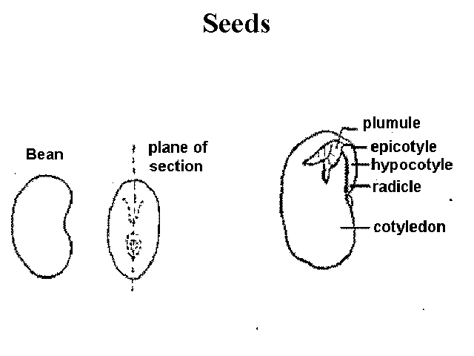

**Seed Identification Procedure**

**Bean Identification Dichotomous Key**

**Directions: Sort your beans according to the kind. Use the bean key to find the name of each bean based on you observations. When you identify a bean, glue it to your paper and label it.**

1A. Is your bean round? If yes, go to 2.

1B. Is your bean bean-shaped? If yes, go to 4.

2A. Does your bean have a flat side and a round side? If yes, go to 3.

2B. Does your bean have two flat sides? If yes, it is a lentil.

3A. Is your bean green? If yes, it is a green pea.

3B. Is your bean yellow? If yes, it is a yellow pea.

4A. Is your bean one color? If yes, go to 5.

4B. Is your bean more than one color? If yes, go to 11.

5A. Does your bean have flat sides? If yes, go to 6.

5B. Does your bean have rounded sides? If yes, go to 7.

6A. Is your bean longer than 20mm? If yes, it is a lima bean.

6B. Is your bean shorter than 20mm? If yes, it is a small lima bean.

7A. Is your bean shorter than 11 mm? If yes, go to 8.

7B. Is your bean longer than 11 mm? If yes, go to 9.

8A. Is your bean white? If yes, it is a small northern bean.

8B. Is your bean black? If yes, it is a black bean.

9A. Is your bean shorter than 16mm? If yes, go to 10.

9B. Is your bean longer than 16mm? If yes, it is a kidney bean.

10A. Is your bean white? If yes, it is a large northern bean.

10B. Is your bean dark red? If yes, it is a red bean.

10C. Is your bean pinkish tan? If yes, it is a pink bean.

11A. Does your bean have stripes and spots? If yes, go to 12.

11B. Does your bean have one black circle? If yes, it is a black-eyed pea.

12A. Is your bean tan and brown? If yes, it is a pinto bean.

12B. Is your bean tan and dark red? If yes, it is a cranberry bean.

**Dissection Procedure**

1. Answer the pre-lab questions prior to beginning your dissection.
2. Place the seed on a paper towel or dissecting tray. Using the probes, gently separate the cotyledons. Illustrate what you see on your data sheet.
3. Place the seed under a dissecting microscope or view it under a hand held magnifying glass. Illustrate what you see now.
4. Answer the analysis questions.