PLANT STEM
A. Anatomical Structure
1. Dicot Stem
• Dicot stem with primary growth have pith in the center, with vascular bundles forming a
distinct ring visible when the stem is viewed in cross section. The outside of the stem is
covered with an epidermis, which is covered by a waterproof cuticle. The epidermis also may
contain stomata for gas exchange and multicellular stem hairs. A cortex consisting of
Hypodermis (collenchyma cells) and Endodermis (starch containing cells)is present above the
pericycle and vascular bundles.

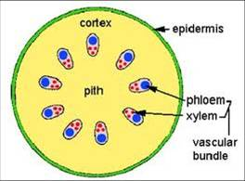
2. Monocot Stem
• Vascular bundles are present throughout the monocot stem, although concentrated towards
the outside. This differs from the dicot stem that has a ring of vascular bundles and often none
in the center. The shoot apex in monocot stems is more elongated. Leaf sheathes grow up
around it, protecting it. This is true to some extent of almost all monocots. Monocots rarely
produce secondary growth and are therefore seldom woody, with Palms and Bamboo being
notable exceptions. However, many monocot stems increase in diameter via anamolous
secondary growth.
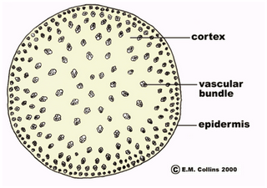
B. Morphological Structure
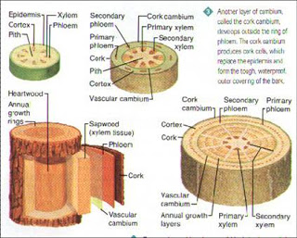
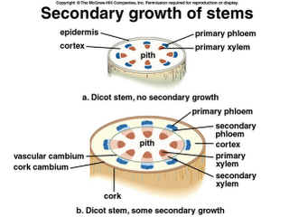

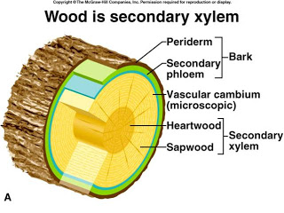
C. The Function of Stem
• The stem plants exist in a variety of sizes and forms. However, all stems provide a few
important functions:
• PRIMARY FUNCTIONS:
• i) provide support for the plant
• ii) provide transportation between roots and leaves
• iii) act as a site for food storage
• ADDITIONAL FUNCTIONS:
1. protection with their help of spines and thorns
2. they have the tendrils to support the plant such as in climbers
3. storage of food suchas in the nodes and internodes of ginger, pot

