Name___________________________________
Period_____

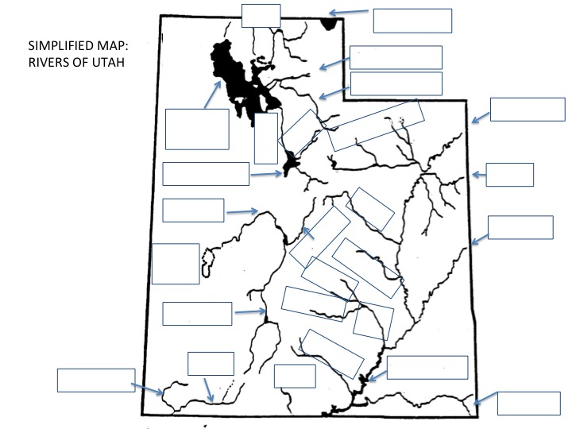

Major Rivers of Utah

Bear River
San Juan River
Colorado River
Price River
Dirty Devil River
Jordan River
Weber River
Green River
San Pitch River
Virgin River
Ogden River
Provo River
Muddy River
Santa Clara River
Sevier River
Paria River
White River
Duchesne River
Fremont River
Escalante River

