Label the following US Rivers:

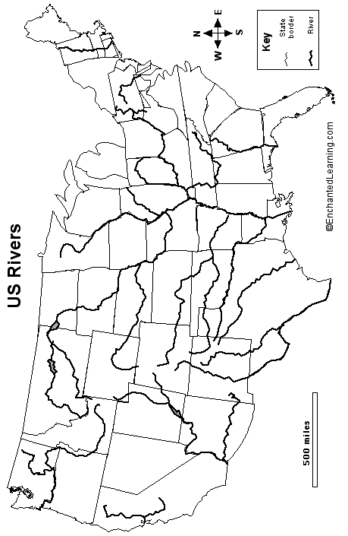

Major US Rivers (in order by length):
River, Length in miles (flows into)
1. Missouri, 2,540 miles (flows into Mississippi River)
2. Mississippi, 2,340 miles (flows into Gulf of Mexico)
3. Rio Grande, 1,900 miles (flows into Gulf of Mexico)
4. St. Lawrence, 1,900 miles (flows into Gulf of St. Lawrence)
5. Arkansas, 1,460 miles (flows into Mississippi River)
6. Colorado, 1,450 miles (flows into Gulf of California)
7. Red, 1,290 miles (flows into Mississippi River)
8. Brazos, 1,280 miles (flows into Gulf of Mexico)
9. Columbia, 1,240 miles (flows into Pacific Ocean)
10. Snake, 1,040 miles (flows into Columbia River)
11. Platte, 990 miles (flows into Missouri River)
12. Ohio, 981 miles (flows into Mississippi River)
13. Pecos, 926 miles (flows into Gulf of Mexico)
14. Canadian, 906 miles (flows into Arkansas River)
15. Tennessee, 886 miles (flows into Ohio River)
16. Colorado, 862 miles (flows into Matagordo Bay)
17. Green, 730 miles (flows into Colorado River)
18. Yellowstone, 692 miles (flows into Missouri River)
19. Gila, 630 miles (flows into Colorado River)

Refs. Encyclopedia Britannica and Kammerer, J.C., May, 1990, Largest Rivers in the United States, US Geological Survey Fact Sheet, Open File Report 87-242.

Note: Measuring the exact length of a river is diffcult, and the length can change over time. Many references cite different lengths for the same river. Averages have been taken in these cases.

