FLAMES AWAY!
Accurately color your observations using the spectroscope. Label each element, and the high and low energy ends of the white light spectrum.

Wavelength

4
5
6
7
Wavelength

4
5
6
7

Spectrum of white light Element Name _________________
Wavelength

4
5
6
7
Wavelength

4
5
6
7

Element Name ___________________ Element Name _________________

4
5
6
7

4
5
6
7

Element Name _____________________ Element Name _________________

Wavelength

4
5
6
7
Wavelength

4
5
6
7

Element Name _____________________ Element Name _________________
Wavelength

4
5
6
7
Wavelength

4
5
6
7

Element Name _____________________ Element Name _________________
Questions: Answer the following questions using your results from the lab, reference page, and the following website.
Website:
http://www.behsscience.com/flamelab
- Why is there no light in certain regions of the atomic spectra of elements?

- Color each emission arrow a different color on the following diagram for the hydrogen atom (using only the colors: red, purple, blue, and green). Account for your coloring.

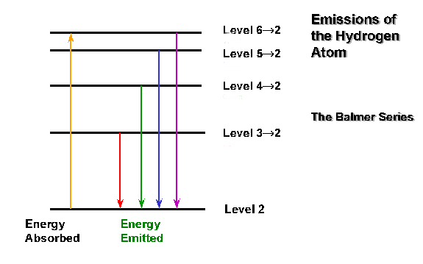
__________________________________________________________________________________________________________________________________________________________________________________________________________________________________________

- Identify the two unknowns and explain how you came to this conclusion.

- A certain Noble gas spectral tube has been left in the lab without a label. How could you identify what Noble gas it is? Go and look at the spectral tube. What is the Noble Gas?

- Based on your observations what is the relationship between wavelength and energy? Justify your answer with evidence from this lab.

