Chemistry Name _________________________

Period_________

Metric calculations and conversions 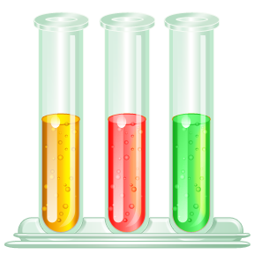
Convert:

- 3.46 centigrams to milligrams

- 1.00 kilograms to centigrams

- 24.0 milligrams to kilograms

- 247 milligrams to grams

- 1.71 millimeters to centimeters

6. 405 mL to cm³

- 750 cm to dm

- 25.0 m to cm

- 35.5 cmto dm

- 5.00 km/hr to m/sec

Chemistry A Name______________________

Period_____

Basic calculations and significant digits

Perform the following calculations and express the answers in the correct number of significant digits.

1. (35.72) (0.00590) 2. (707,000) (3.1)

3. (0.05432) (62,000) 4. (0.0059000) (38.76)

5. 6810.12 / 2.4 6. 0.4832 / 5.12

7. 201 + 3.57 + 98.493 8. 5.32 – 0.75938

9. (6.09 x 10⁻¹) (9.08 x 10⁵) 10. (1.65 x 10¹) (5.24 x 10²)

11. (1.10 x 10⁹) (4.75 x 10⁹) 12. (1.18 x 10⁻²) (2.20 x 10³)

13. (8.17 x 10¹) (8.70 x 10⁵) / (4.20 x 10⁵)

- (4.87 x 10⁶) (9.69 x 10¹) / (2.84 x 10⁶)

- (7.79 x 10⁴) (6.45 x 10⁴) / (5.44 x 10⁶) ( 7.45 x 10⁻¹)

- (7.69 x 10²) (6.56 x 10⁶) / (2.92 x 10⁴) (1.65 x 10⁴)

- (9.19 x 10⁷) (1.79 x 10¹) / (8.17 x 10⁴) (8.32 x 10⁷)

18. (6.40 x 10²) (9.97 x 10⁴) / (6.12 x 10⁻²) (9.71 x 10⁴)

