Name________________________Period_______
Tree Rings
Use the Tree Cookie to answer the questions.
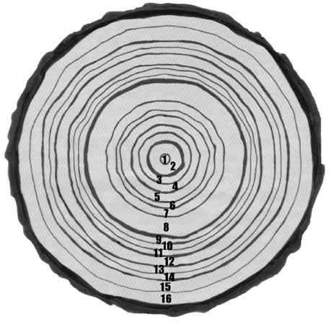
a. This tree was cut 3 years ago. Write that year:
b. How old was the tree?
c. What year did the tree start growing?
d. Find the ring that grew the year you were born. Was it a wet or dry year?
e. In what year of growth was there the least rainfall?
f. In what year of growth was there the most rainfall?

5. Reading the Rings
To help figure out what climate the tree grew in and what the environment was like, look at each ring:
- Thickness
How wide a ring is can tell you if the environment was good or bad for the tree to grow in.
In years when the amount of rain and temperature were good a tree's rings are wider.
In bad years a tree's rings are thinner.
- Shape
If rings become thinner on one side than the other it means the tree is leaning over to one side.
High winds or a big storm can cause a tree to lean.
- Strange Marks
Dr. Fir also looks for strange marks, like scars, and other "pieces of evidence."
Scars can be left by insects or disease. A forest fire can leave burnt marks.
Reading the Rings (continued)
Look at these cross sections and match them to the event that caused them.
