Tree Cookies
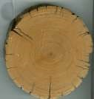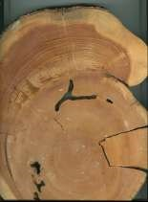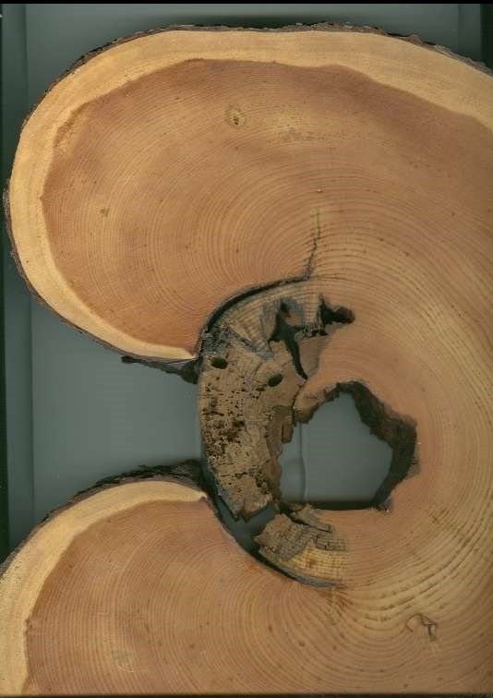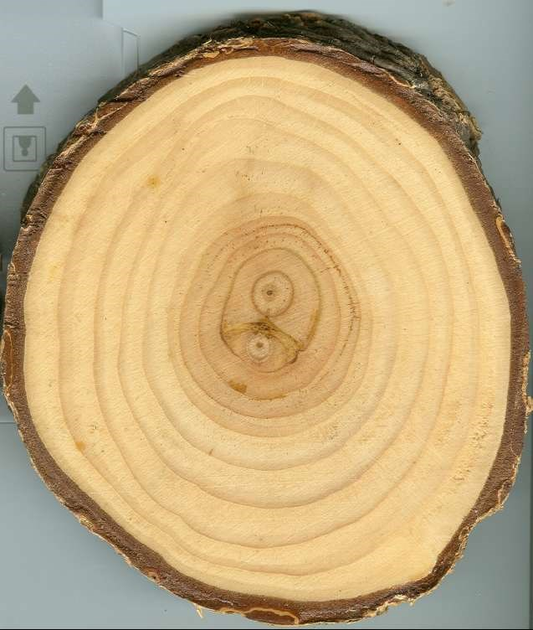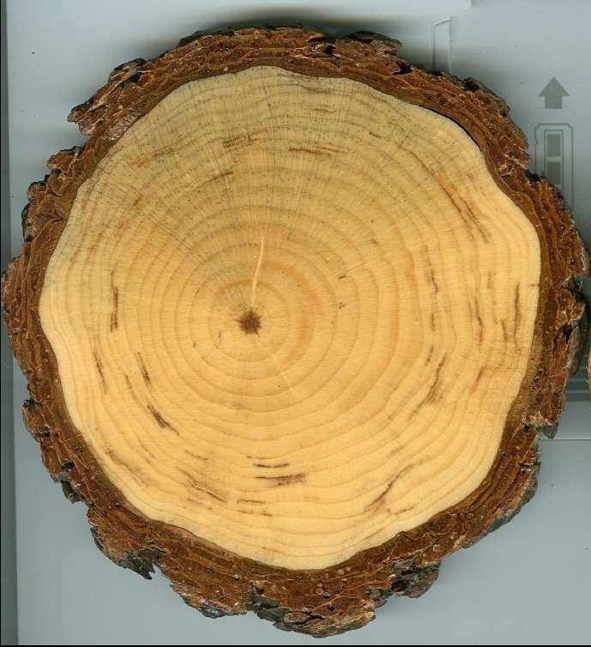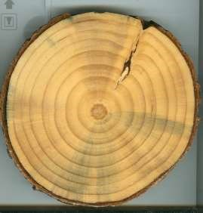

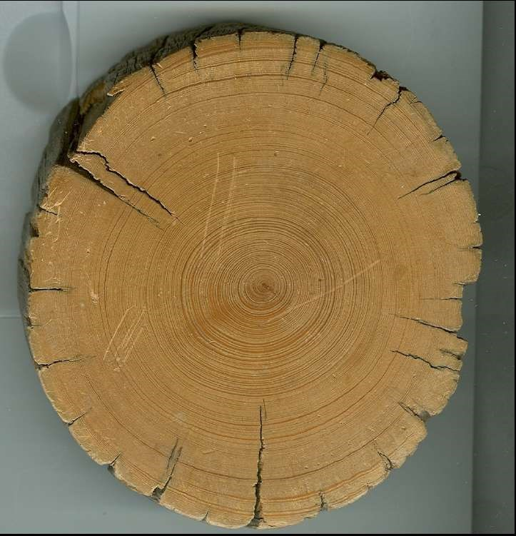

Bristlecone Pine
Actual size about 3 ½ inches across. This sample was from a branch (dead) that was on a living
tree. Because branch was dead when this was
cut, there are cracks on outside and no bark left. Note how close rings are.
How old was this branch?
How many years in one inch of growth

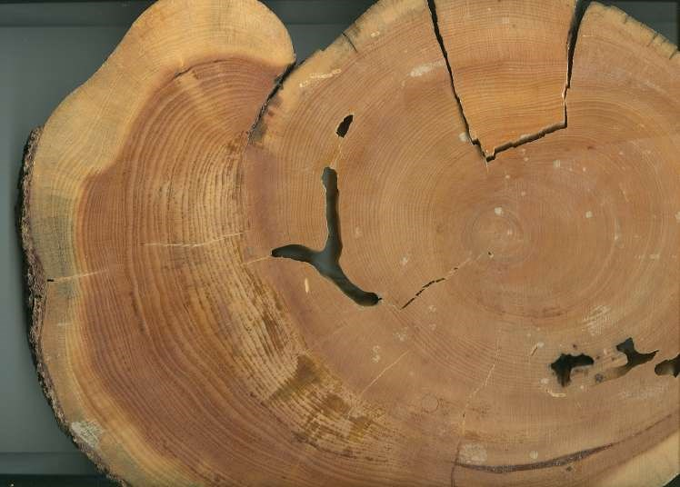

Lodgepole Pine
This specimen was from a Lodgepole Pine that was burned. Look at the rings surrounding the scar and
notice how they were trying to cover over the damage cambium layer.
What do you think made the tunnels in the middle of tree?
Most likely these were from carpenter ants that eat only dead wood. Because this cross-section became brittle with use, there is a section that broke out.

Another large pine cross-section. Another tree that burned. Note how the tree was
trying to close the wound with additional
growth rings – but the dead tissue became decayed before it was sealed off from organisms that create wood decay.
What might be a benefit of decay in trees – especially in the middle of the tree?

This tree was about 4 inches across. It is from a Ponderosa pine that was in a stand of thinned trees near Boise, ID. Note the two centers of the tree. When the tree was young, there must have been two leaders – but later one of these leaders died or was removed.
How old is this tree?
Note the different texture in the rings – the dark part of the ring is the latewood (little water and growth is slowing down) and light part of ring is springwood or early wood (when there is fast growth due to lots of water).
Can you locate where the cambium would be?
How about the phloem?

Another cross-section of a Ponderosa pine – actual size was about 4 inches across. Note the center of tree (called the pith) is not exactly in the center of the cross-section. Some trees grow better on the
sunny side of the tree or where the root system is able to get more water.
Do you notice the dark lines partly around the growth rings?
These are pitch pockets – possibly natural or from sort of damage to the tree. Notice also the blue- grayish stain. This is from blue stain fungus – often carried by bark beetles.
The fungus spreads across the cross-section and can plug the cells.
The ray cells which are the cells going from outside of the tree toward the middle of the tree are more obvious due to the blue stain fungus.

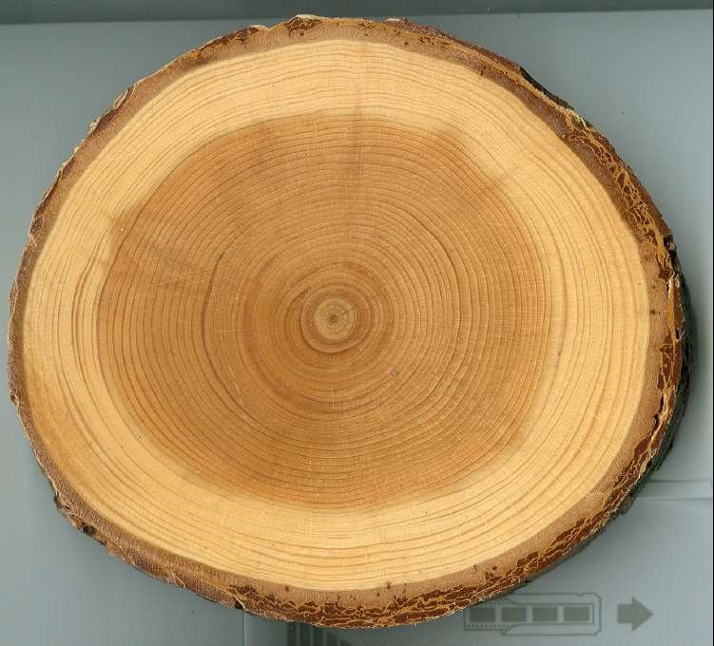

This Ponderosa pine cross-section is about 4 inches across. Notice how much older this sample is from the one on page 4 and page 5. This sample came from a tree in the same area as the two other trees.
Why do you think the growth is so different?
(Hint- it is not because of different weather or rainfall.)
Answer – this sample came from a crowded forest stand. Each tree had much less sunlight and water per tree, thus the growth slowed down greatly. Note the color of the inside rings is much darker. As
growth rings get older, they store other chemicals in the process of the cells dying and no longer moving water.

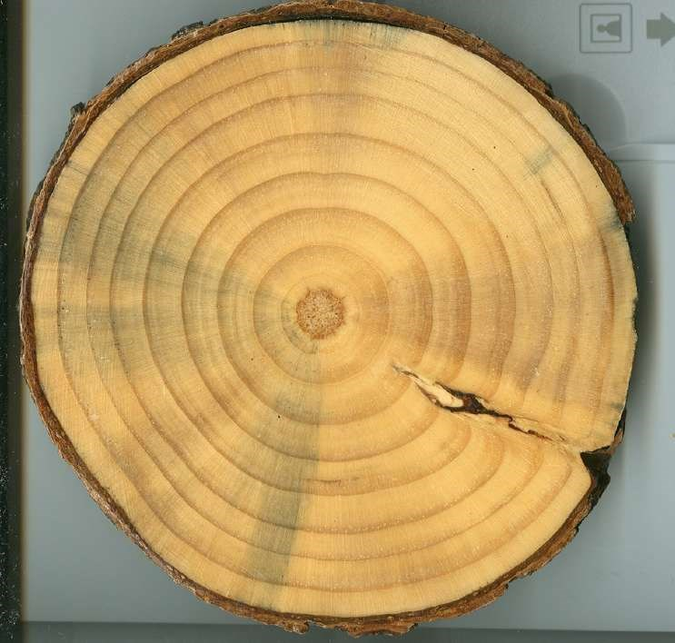

Here is another pine that is 4 inches across. This sample shows clearly how the blue stain travels in the ray cells toward the middle of the tree.
Note the way the growth rings appear – you can see quite a bit of detail of the cells in this scan.
Note the scar across the cross-section. This is from a branch growing out of the tree.
What year did the branch start growing?

