SURVIVAL BASICS
The advances in the development of outdoor clothing, equipment, emergency food and techniques have been growing rapidly in recent years. For those beginners interested in using the outdoors there is unlimited information available. However, experience is the best teacher in any outdoor situation and your reaction in a survival situation depends on your education. Always keep in mind that it can happen to you. Those who are mentally and physically prepared to survive are more likely to do so. To deal with an emergency situation one must be able to make decisions, improvise and remain calm.
Fear - For anyone faced with an emergency situation, fear is a normal reaction. Unless an emergency situation has been anticipated, fear is generally followed by panic then pain, cold, thirst, hunger, fatigue, boredom and loneliness. It is extremely important to calmly assess the situation and not allow these seven enemies to interfere with your survival.
Pain - Pain may often be ignored in a panic situation. Remember to deal with injuries immediately before they become even more serious.
Cold - Cold lowers the ability to think, numbing the body and reducing the will to survive. Never allow yourself to stop moving or to fall asleep unless adequately sheltered.
Thirst - Dehydration is a common enemy in an emergency situation and must not be ignored. It can dull your mind, causing you to overlook important survival information.
Hunger - Hunger is dangerous but seldom deadly. It may reduce your ability to think logically and increase your susceptibility to the effects of cold, pain and fear.
Fatigue - Fatigue is unavoidable in any situation so it is best to keep in mind that it can and will lower your mental ability. Remember that in an emergency situation this is often the bodies way of escaping a difficult situation.
Boredom & Loneliness - These enemies are quite often unanticipated and may lower the mind's ability to deal with the situation.

HOW TO:
Build a Fire - Building a fire is the most important task when dealing with survival in the wilderness. Be sure to build yours in a sandy or rocky area or near a supply of sand and water as to avoid forest fires. The most common mistakes made by those attempting to build a fire are: choosing poor tinder, failing to shield precious matches from the wind and smothering the flames with too large pieces of fuel. The four most important factors when starting a fire are spark - tinder - fuel - oxygen.
The most common ways to create spark are:
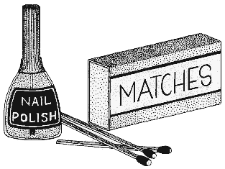1. Waterproof, strike-anywhere matches are your best bet. Matches may be water-proofed by dipping them in nail polish. Store your matches in a waterproof container.
2. A cigarette lighter is also a good way to produce a spark, with or without fuel.
3. The flint and steel method is one of the oldest and most reliable methods in fire starting. Aim the sparks at a pile of dry tinder to produce a fire.
4. The electric spark produced from a battery will ignite a gasoline dampened rag.

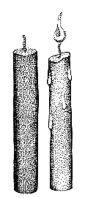5. Remove half of the powder from a bullet and pour it into the tinder. Next place a rag in the cartridge case of the gun and fire. The rag should ignite and then may be placed into the tinder.
6. Allow the suns rays to pass through a magnifying glass onto the tinder.
Dry grass, paper or cloth lint, gasoline-soaked rags and dry bark are all forms of tinder. Place your tinder in a small pile resembling a tepee with the driest pieces at the bottom. Use a fire starter or strip of pitch if it is available.
It is important to keep in mind that smaller pieces of kindling such as, twigs, bark, shavings and gasoline, are necessary when trying to ignite larger pieces of fuel. Gather fuel before attempting to start your fire. Obviously dry wood burns better and wet or pitchy wood will create more smoke. Dense, dry wood will burn slow and hot. A well ventilated fire will burn best.

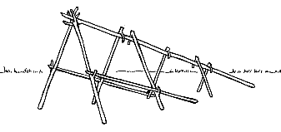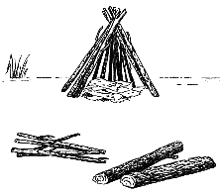Build a Shelter - A small shelter which is insulated from the bottom, protected from wind and snow and contains a fire is extremely important in survival. Before building your shelter be sure that the surrounding area provides the materials needed to build a good fire, a good water source and shelter from the wind.
Wilderness shelters may include:
1. Natural shelters such as caves and overhanging cliffs. When exploring a possible shelter tie a piece of string to the outer mouth of the cave to ensure you will be able to find your way out. Keep in mind that these caves may already be occupied. If you do use a cave for shelter, build your fire near its mouth to prevent animals from entering.
2. Enlarge the natural pit under a fallen tree and line it with bark or tree boughs.
3. Near a rocky coastal area, build a rock shelter in the shape of a U, covering the roof with driftwood and a tarp or even seaweed for protection.
4. A lean-to made with poles or fallen trees and a covering of plastic, boughs, thick grasses or bark is effective to shelter you from wind, rain and snow.

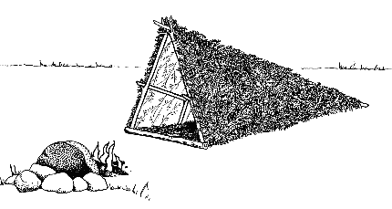5. A wigwam may be constructed using three long poles. Tie the tops of the poles together and upright them in an appropriate spot. Cover the sides with a tarp, boughs, raingear or other suitable materials. Build a fire in the center of the wigwam, making a draft channel in the wall and a small hole in the top to allow smoke to escape.
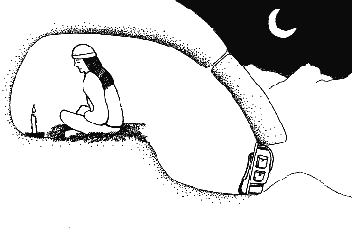6. If you find yourself in open terrain, a snow cave will provide good shelter. Find a drift and burrow a tunnel into the side for about 60 cm (24 in) then build your chamber. The entrance of the tunnel should lead to the lowest level of you chamber where the cooking and storage of equipment will be. A minimum of two ventilating holes are necessary, preferably one in the roof and one in the door.

CLOTHING AND EQUIPMENT
Clothing - Clothing must provide warmth and offer protection from the elements. Layers of light, natural fibers are best. Hats are a must, as they offer protection from both the heat and cold. Water proof outer layers are necessary.
Equipment - Equipment must be easily manageable and promote survival in any situation. Items to carry in your pockets may include a fire starter, waterproof matches and/or lighter, a pocket knife, goggles, compass, small first-aid kit and some sort of trail food.
Survival kit - Items should be packed in a waterproof container that can double as a cooking pot and water receptacle and be attached to your belt.
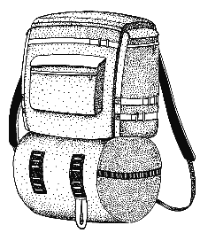Backpack - A good, comfortable backpack is mandatory. Loads of about 18 kg (40 lb.) are average. Items to include are; flashlight, extra jacket, socks and mittens, a pocket saw, gas camp stove, first-aid kit, emergency food, and a tent and fly.
CHECK LIST Useful items to include on your hike are:
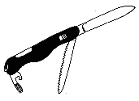1. A map and compass.
2. A large, bright plastic bag will be useful as a shelter, signaling device or in lieu of raingear.
3. A flashlight with extra batteries.
4. Extra water and food.
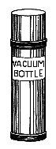5. Extra clothing such as raingear, a toque and gloves, a sweater and pants.
6. Sun protection such as sunglasses, sunscreen, a hat and long sleeved clothing.
7. A sharp pocket knife.
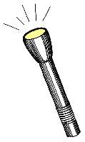8. Waterproof matches, a lighter and/or a flint.
9. Candles and fire starter.
10. A first aid kit.
11. A whistle, flares, a tarp.

Before venturing into the wilderness check weather forecasts and hazards.

FINDING FOOD & WATER
It is possible to live for extended periods of time on little or no food. Research shows that a healthy individual can survive on 500 calories a day with no side effects and with plenty of water and a comfortable resting place can live approximately three weeks without food. During cold weather or periods of heightened activity more food is required to maintain a normal body temperature.
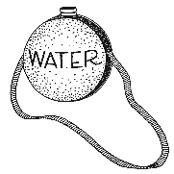Water is much more important. Two to three cups of water are required each day to stay healthy. It is wise to conserve the water in your body by reducing activities that may promote water loss.
Finding water during the summer months is quite easy. Running water such as springs or streams in isolated areas is generally safe for consumption but be aware that water in stagnant areas such as sloughs and ponds may carry disease and should either be boiled for a 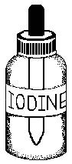minimum of three minutes, or iodine (nine drops per quart) or halazone tablets added. It is wise to carry a water purification pump with you. This allows the hiker to make use of stagnant water in any situation and it is not necessary to carry water with you. In areas where no surface water is available, dig into damp soil and allow this muddy water to settle and become clear. Water may also be found on the dew of plants, by collecting rainwater or in fish juices.
During the winter months it is wise to look for water under ice. Melting ice as opposed to snow is more fuel efficient. Remember that hard-packed snow will yield more water than light, fluffy snow. Do not eat snow as it tends to dehydrate the body.
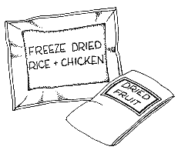Finding food in the wilderness may prove slightly more difficult but by no means impossible. Try and sustain with natural foods before using your emergency survival kit rations. If water is not readily available try to limit your food consumption to carbohydrates, as proteins use more water to digest. Keep in mind that all fur-bearing animals and grass seeds are edible and that there is more food value in the roots of plants than the greens. Extra care should be taken when consuming seafood. Try to avoid mussels during the summer months as they contain certain toxins which are not present during the winter. Sea urchins, a prickly purple or green sea creature, may be consumed by breaking them open and eating the red or yellow eggs inside. Steam snails, clams and limpets. Frogs, snakes, lizards and birds are also edible. Remove the head, entrails and skin before adding them to the pot.

POISONOUS PLANTS
Care should be taken when consuming any unknown plant in the wilderness. Avoid red and white berries, and plants resembling beans, melons and cucumber as they are often poisonous. There are a large variety of mushroom species, most are edible but some are extremely dangerous and should be avoided unless you can positively identify them. Water hemlock is a particularly poisonous plant which is found in swampy areas of British Columbia. It grows up to two meters, with hollow roots and small white flowers. The dangerous baneberry plant grows up to one meter tall and produces small white flowers and white or red berries.

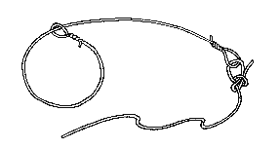FISHING & HUNTING
Setting snares, traps, nets and set lines will assist you in finding food to help with your survival. Trails are excellent places to set snares. Animal tracks offer information pertaining to the type of animal, its size and the direction it was headed. Following these tracks will often lead to water-holes and feeding grounds where you may use your traps or snares.

TRAVEL
If you do become lost, stay where you are. Build a fire and carefully assess the situation. Do not use precious energy by wandering aimlessly.
During the winter months use game trails which will help you avoid walking in the deep snow. Frozen streams and rivers are also easy to follow but watch for weak ice.
When measuring distance the most effective method is the tally and pace system:
1 pace = 75 cm (29.25 in)
1 double pace = 150 cm or 1.5 m (58.5 in)
66 double paces = 99 m (107.9 yards) = 1 tally (tie a knot in a string for each tally)
10 tallies = 1000 m or 1 km (0.62 mi)

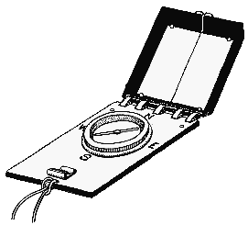FINDING DIRECTION
Using a Compass -
A magnetic-Sylva type compass is a lost hiker's best friend. First, decide which direction you want to follow then aim over the centre of your compass to the bearing you want to follow and find a landmark on this sighting. After arriving at this landmark repeat the process. Using this pattern you will follow a relatively straight line.
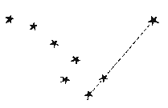Using the Stars - For those unfortunate enough to not have a compass, using the pole star for direction will suffice. Simply located the pole star and you will be facing north. To find this star use the Big Dipper constellation. The pole star will be located off of the top of the "dipper", on the opposite side of the handle.
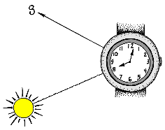Using the Sun - You may also use your watch and the sun to determine direction. Point the hour hand directly at the sun and then bisect the angle between the hour hand and twelve o'clock. This imaginary line will run north/south.

METHODS OF NAVIGATION
There are three common methods of navigation:
1. Map reading is a common method used, particularly in developed areas. Maps and aerial photos may be used when landmarks are clear.
2. Using a compass in conjunction with maps and aerial photos is wise in areas without good landmarks.
3. Navigation by dead reckoning is common in areas where landmarks are non-existent or inadequate. This method combines plotting and recording of a series of courses, measured by distance and direction from a starting point.
* It is important to stay alert and observe all unusual landmarks.
Difficulties in navigation may occur for several reasons. Some of these include

WHEN YOU'RE LOST
The most important thing to remember if you find yourself in this situation is not to panic. First, treat any injuries within your party. Next, establish that your basic needs are met. These include heat, shelter, water and food. Then consult your map and compass and try to recognize or remember landmarks you may have passed.
To determine how many hours of daylight are left, face the sun and extend your arm towards it. Bend your wrist inwards and place your fingers just below the sun. Disregarding your thumb, count how many fingers separate the sun from the horizon. Each finger will represent fifteen minutes.
If it is nearing dark, build a shelter and fire that is on high ground and out of the wind. Have a snack and a hot drink and get some rest. Don't waste precious energy by trying to find your way in the dark.
During daylight hours it is important to find a way to signal to others. A fire is best. Be sure to find a means with which to carry water. If you must move be sure to leave markers that searchers can follow.

SIGNALS
A fire is the safest method to use when signaling for help. The smoke is easily spotted during the day and the flames by night. Three signal fires laid 30 m (98 feet) apart and lit when a aircraft passes is a good way to indicate your distress. The Morse Code emergency signal is S...O...S... and may be sent with a flashlight and consists of three dots followed by three dashes followed by three dots. The dashes should be twice as long as the dots. Messages or signal letters may be drawn in the snow. A signal mirror is also a very effective method used. Flash the mirror along the horizon regardless of whether a plane is in view.

FIRST AID & HEALTH

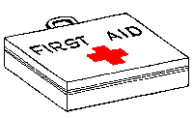When journeying into the wilderness it is important to carry a complete first aid kit and book. It is also wise to take a first aid course. A good diet, cleanliness and appropriate clothing will lower the risk of harmful situations.
Disease, infection and often, insect bites can be avoided when maintaining a proper diet. It is important to bathe daily but if this is not possible be sure to wash your hands frequently. Soap can be made using ashes and animal fat or by boiling the inner bark of a pine tree. Construct a toothbrush by mashing the end of a green twig. When setting out for your journey remember to pack a wide range of clothing and extra footwear.

FIRST AID
If an accident occurs in the wilderness it will be your responsibility to deal with the situation. The specific sequence of actions when dealing with this situation is:
1. Remain calm, providing your patient with quiet, efficient first aid treatment.
2. Keep the patient warm and lying down. Do not move this injured person until you have discovered the extent of the injuries.
3. Start mouth-to-mouth artificial respiration immediately if the injured person is not breathing.
4. Stop any bleeding.
5. Give your patient reassurance. Watch carefully for signs of shock.
6. Check for cuts, fractures, breaks and injuries to the head, neck or spine.
7. Do not allow people to crowd the injured person.
8. Do not remove clothing unless it is imperative.
9. Decide if your patient can be moved to a proper medical facility. If this is not possible, prepare a suitable living area in which shelter, heat and food are provided.

SHOCK
Shock is a depression of all of the body processes and may follow any injury regardless of how minor. Factors such as hemorrhage, cold and pain will intensify shock. When experiencing shock the patient will feel weak and may faint. The skin becomes cold and clammy and the pulse, weak and rapid. Shock can be more serious than the injury itself.
Use the following method to prevent and control shock:
1. When treating injuries:
i. restore breathing
ii. stop bleeding
iii. treat breaks and fractures
2. If there are no head or chest injuries place the patient on his/her back with the head and chest lower than the legs. This will help the blood circulate to the brain, heart, lungs and other major organs.
3. If severe head and chest injuries are present elevate the upper body. If chest injuries are present, elevate the injured side to assist in the functioning of the uninjured lung.
4. If the injured person becomes unconscious, place him/her in a face down position to prevent choking on blood, vomit or the tongue.
5. Keep your patient warm and under shelter.

STOPPED BREATHING
If breathing has stopped, begin mouth-to-mouth resuscitation. Place the patient on his/her back and follow these steps:
1. To open the airway lift the patient's neck and tilt the head back.
2. Keeping the neck elevated, pinch the nostrils to prevent air leakage.
3. Place your mouth completely around the victim's mouth and blow, watching for chest expansion.
4. After removing your mouth, listen for air leaving the patient's lungs and watch for the chest to fall. Check for an airway blockage if the chest does not rise.
Repeat these steps approximately 12 to 15 times per minute. If treating a child, cover the nose and mouth with you mouth. Use smaller puffs of air and repeat this method 20 to 25 times per minute.

BLEEDING
To control bleeding, elevate the wounded area above the heart and apply pressure using either gauze, clean cloth, dried seaweed or sphagnum moss. Use pressure at the pulse point between the injured area and the heart if bleeding fails to stop. If bleeding still persists, use a tourniquet between the injury and the heart. This method should only be used in extreme situations. After bleeding has been controlled, wash the wounded area with disinfectant and apply a dressing and bandages.

FRACTURES
A fracture is classified as either a simple (closed) or compound (open). Signs that a fracture is present include:
1. Pain at the affected area.
2. The area may or may not be deformed.
3. The victim is unable to place weight on the area without experiencing pain.
4. A grating sensation or sound may be present during any motion of the injured area.
Treatment is as follows:
1. If in doubt, treat the injury as a fracture.
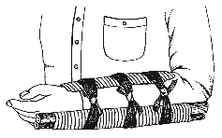2. Splint the joints above and below the fracture.
3. If the fracture may penetrate the skin, it could be necessary to apply traction to straighten the deformity.
4. Be sure to pad your splints.
5. Check the splint ties frequently to be sure they do not hinder circulation.
6. Cover all open wound with a clean dressing before splinting.

DISLOCATION
Dislocation happens when the ligaments near a joint tear, allowing the movement of the bone from its socket. It is unwise to treat a dislocation unless you are a trained professional as permanent damage may occur. The affected extremity should be supported using a sling or other device and pain controlled with aspirin or other suitable drugs.

SPRAINS
Treat sprains by applying cold to the area for the first 24 hours then once the swelling has subsided, let the sprain sit for a day. Apply heat the following day to aid in the healing process. The sprain should be splinted and rendered immobile until the pain has completely disappeared.

CONCUSSIONS
Concussions or other head injuries are often accompanied by a leakage of watery blood from the nose or ears. Other symptoms may include convulsions, an unresponsiveness of the pupils or headache and vomiting. Keep the injured party warm, dispense a pain killer regularly and allow time for the body to rest and repair.

HEAT EXHAUSTION
Heat exhaustion is not uncommon when water is not sufficient. The body becomes dehydrated and salt-depleted, resulting in nausea, faintness, a weak, rapid pulse and/or cold and clammy skin. Treatment includes plenty of rest, liquid and salt tablets.

SUNSTROKE
Sunstroke may occur when the body is exposed to excessive sun. The body becomes overheated and provides too much blood to the circulatory system resulting in a flushed, hot face, rapid pulse, headache and/or dizziness. Treat sunstroke by resting in a cool area and applying and consuming cold liquid. Prevent sunstroke by wearing proper headgear.

MUSCLE CRAMPS
Muscle cramps occur when the muscle accumulates excessive lactid acid or a loss of salt through perspiration. Treatment includes resting, deep breathing and stretching. Restore the salt balance immediately.

BURNS
Burns are most commonly followed by shock. Administer a pain reliever immediately, apply gauze covered in Vaseline to the affected area and bandage. The patient should consume more water than usual.

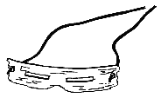SNOWBLINDNESS
Symptoms of snowblindness include scratchy or burning eyes, excessive tearing, sensitivity to light, headache, halos around light and temporary loss of vision. Bandage the victim's eyes and use cold compresses and a painkiller to control the pain. Vision will generally be restored after 18 hours without the help of a doctor. Always wear snow goggles or sunglasses in snowy areas to prevent snowblindness.

FROSTBITE
Frostbite occurs when the tissue of an area, most commonly the toes, fingers or face, is frozen either from direct exposure to the elements or high wind. First degree frostbite turns the area cold, white and numb. When heated the area becomes red and can be compared to a first degree burn. A blister will form after warming with second degree frostbite. Dark skin, gangrene, and a loss of some skin and tissues is common in third degree. Fourth degree frostbite causes irreparable damage. The affected area will remain cold and lifeless and generally a part of the area is lost. With adequate clothing frostbite can easily be avoided. Superficial frostbite may be treated by cupping one's hands and blowing on the affected area, warming from another warm hand or, with fingers, placing them in your armpits. For more severe cases, medical aid should be sought.

BLISTERS
Blisters are the painful, and common, result of ill-fitting footwear. At the first sign of discomfort, remove boots and socks and place a piece of adhesive tape over the affected area. If it is absolutely necessary, open a blister by first washing the area thoroughly then inserting a sterilized needle into the side of the blister. Apply disinfectant and a bandage.

HEADACHES
Headaches are often experienced in the mountains due to inadequate eye protection, tension in the neck, constipation or "water intoxication", a swelling of the brain tissue which happens when the hiker has sweated excessively over a period of days and consumed large quantities of water without taking salt tablets. Aspirin may be used to alleviate the pain but one should find the source of headache to prevent further discomfort.

SNAKE BITES
Snake bites are not overly common. One species of venomous snake, a rattlesnake is found in the dry belt of the southern interior. If you come across a snake slowly ease back. A snake bite rarely causes death; victims may be left untreated for up to eight hours.
After an attack occurs:
1. Keep the person calm, reassuring them that bites can be effectively treated in an emergency room. Restrict movement, and keep the affected area just below heart level to reduce the flow of venom.
2. Remove any rings or constricting items because the affected area may swell. Create a loose splint to help restrict movement of the area.
3. If the area of the bite begins to swell and change color, the snake was probably poisonous.
4. Monitor the person’s vital signs -- temperature, pulse, rate of breathing, blood pressure. If there are signs of shock (such as paleness), lay the victim flat, raise the feet about a foot, and cover the victim with a blanket.
5. Get medical help immediately.

BEE STINGS
Bee stings are common and harmless unless you are allergic. Remove the stinger then apply disinfectant and clod water to reduce the swelling.
A change of diet, dirty cooking utensils or the consumption of tainted water may result in diarrhea which in turn will cause a loss of nutrients and precious body fluids. Take extra care in cleanliness and boil water for an additional three to five minutes to avoid diarrhea.

HYPOTHERMIA
When the temperature of your body falls to a level at which your vital organs can no longer function you are experiencing hypothermia or exposure sickness. Hypothermia will develop rapidly and is caused by cold, wet and/or windy weather that chills the body at a speed faster than it can produce heat. A lack of energy-producing food and proper clothing will heighten the speed at which hypothermia will affect you. Always remember to bring extra clothing. It is important to hike at the speed of the slowest member of your party. Take frequent breaks and keep a close watch for members experiencing signs of fatigue. Exposure sickness generally occurs in temperatures of less than 10 C (50 F).
Symptoms are easily recognizable:
1. Feeling cold and constantly exercising to keep warm.
2. Uncontrollable shivering and numbness.
3. Violent shivers. Your mind becomes slow and starts to wander.
4. Violent shivering ceases and muscles begin to stiffen and become un-coordinated. Exposed skin becomes blue and thoughts are foggy. Victim usually lacks the capability of realizing how serious the situation is.
5. Pulse and respiration slows.
6. Victim will not respond and becomes unconscious.
7. The section of the brain controlling the heart and lungs ceases functioning.

Treatment must be quick and efficient:
1. Move the victim to a sheltered area, out of the elements.
2. Remove wet clothing and replace with dry clothes and if possible, a sleeping bag.
3. Wrap warm rocks and place them near the patient.
4. Do not let the victim fall unconscious.
5. Give the victim a warm, non-alcoholic drink.
6. Allow another person in the sleeping bag to share body heat.
7. Exhale warm air near the vicinity of the patients mouth and nose.

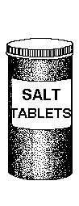HYPERTHERMIA
Hyperthermia is a result of the body being overheated due to increased air temperature, solar or reflected radiation, poorly ventilated clothing, a low fitness level or excess bulk.
Symptoms include:
1. Heat cramps may occur and should be treated by moving the victim to a shady area and supplying water and salt tablets.
2. Heat exhaustion is a mild form of hyperthermia and includes symptoms such as headache, dizziness, fainting, clammy skin, blurred vision, nausea and vomiting. Treatment is the same as heat cramps.
3. Heat stroke is the most serious degree of hyperthermia. The victim will have little or no perspiration, a hot and flushed face, full pulse, and become either apathetic or aggressive. Cool the victim as quickly as possible paying extra attention to the head, neck and chest. If the bodies temperature continues to rise, unconsciousness, delirium, convulsions and ultimately death may occur.
To avoid hyperthermia, avoid strenuous activity on hot days, wear loose clothing and a hat, drink plenty of fluids and take salt tablets.

