Plant Stems Name__________________
Period____
Label the following cross section of a stem:  - _________________  - _________________  - _________________  - _________________ | 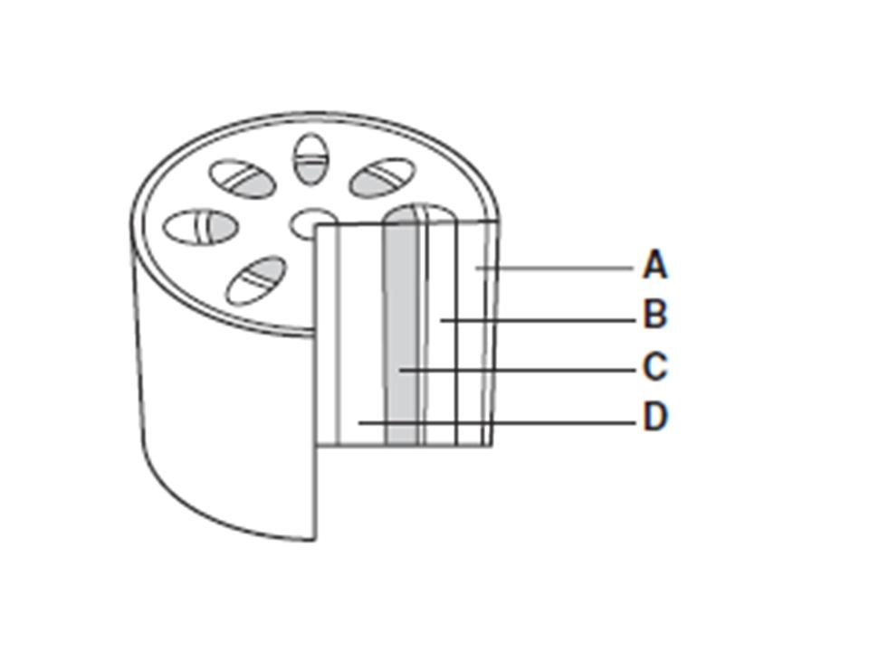
Which of the following is the:  _______1. Terminal Bud  _______2. Axillary Bud  _______3. Node  _______4. Internode  _______5. Scale Scar | 