**Floor Plan symbols**

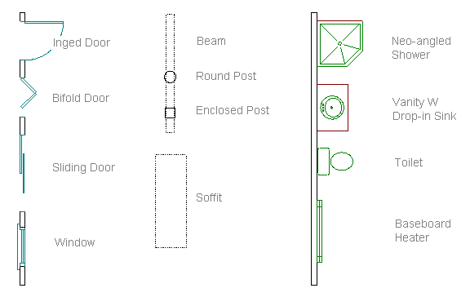

**Floor Plan symbols**

