Aliens!

Objective: Recognize the capability of invasive weeds to spread throughout the United States from a single source.

Vocabulary:
Invasive species (Noxious weed): Species which have the capability to spread unchecked throughout a wide range. It does so because of a lack of natural predators, and because it out-competes native species. The danger of invasive species is that they replace the native ecosystem, forming a monoculture of that species.

Background:
Hydrilla is a submersed plant that was brought to Florida in the 1950’s from Asia to grow in aquariums. Back then hydrilla was planted in canals and rivers and picked to sell in pet stores. Hydrilla can grow more than an inch each day and can fill water bodies that are as deep as 15-20 feet in only one year. When it reaches the water surface, hydrilla grows across the top of the water forming tangled mats of plants. These mats wrap around propellers and make boating almost impossible. They also slow water flow and jam against bridges and dams, which can cause flooding. Hydrilla mats form a cover over water bodies that will not allow light or oxygen into the water, killing native plants, fish, and other wildlife.

Hydrilla does not form seeds. New plants sprout from the roots and from broken stems. Each piece of stem can form its own roots and start a new plant. hydrilla also forms buds on the stems and roots. The root buds, called tubers, can lie in the sand or mud for years before they sprout. Once hydrilla makes tubers, it is almost impossible to eradicate. Ecosystem managers use biological, mechanical, and physical controls along with herbicides to control hydrilla so it causes fewer problems. Because hydrilla can cause so many problems there are now strict laws against owning or planting this prohibited plant in the United States.

Aliens!

Procedure:
Step 1: Track the spread of the hydrilla since it was brought to Florida 50 years ago. Write the number next to the state listed below. Color these states red.
For example, using the list below, hydrilla entered Florida first. Color Florida red and put a #1 in the state of Florida. Repeat the procedure with state number 2, North Carolina.
Step 2: Describe the spread of hydrilla since its arrival. What lessons can we learn from this?

- Florida
- 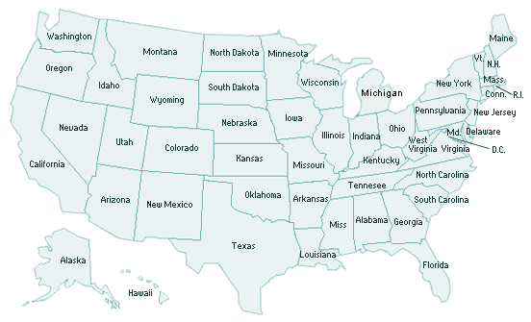North Carolina
- Tennessee
- Louisiana
- Georgia
- Virginia
- Alabama
- Texas
- South Carolina
- Maryland
- Mississippi
- Arizona
- Pennsylvania
- Delaware
- California
- Washington
- Connecticut

Step 3: Name and describe three invasive species which are on Utah’s noxious weed list that counties are obligated to remove. You can look on the web: http://www.utahweed.org/weeds.htm

1.

2.

3.

